- General Information:
  - Hardware information:
  - ARM Cortex M4 CPU :
The new microcontroller model is used in the Cortex-M line of chips. There, the vector table at 0 is actually a table of vectors (pointers), not instructions. The first entry contains the start-up value for the SP register, the second is the reset vector. This allows writing the reset handler directly in C, since the processor sets up the stack. Again, the table can be relocated at runtime. The typical vector table for Cortex-M begins like this:

_Vectors DCD __initial_sp ; Top of Stack
DCD Reset_Handler ; Reset Handler
DCD NMI_Handler ; NMI Handler
DCD HardFault_Handler ; Hard Fault Handler
DCD MemManage_Handler ; MPU Fault Handler
DCD BusFault_Handler ; Bus Fault Handler
DCD UsageFault_Handler ; Usage Fault Handler

  - Proprietary RTOS operating system

- Reverse Process:
  - Firmware sample acquisition.
  - Binary analysis.
  - Firmware disassembly.
  - Deivation firmware update validation method.
    - Searchig symbol names for relevant titles indicative of the validation such as check sum or CRC
  - Determine the validation method (page 47) as well as range of the firmware image covered by the method
  - Using the black box analysis to get information about validation algorithm.

This is assumtion checking value:
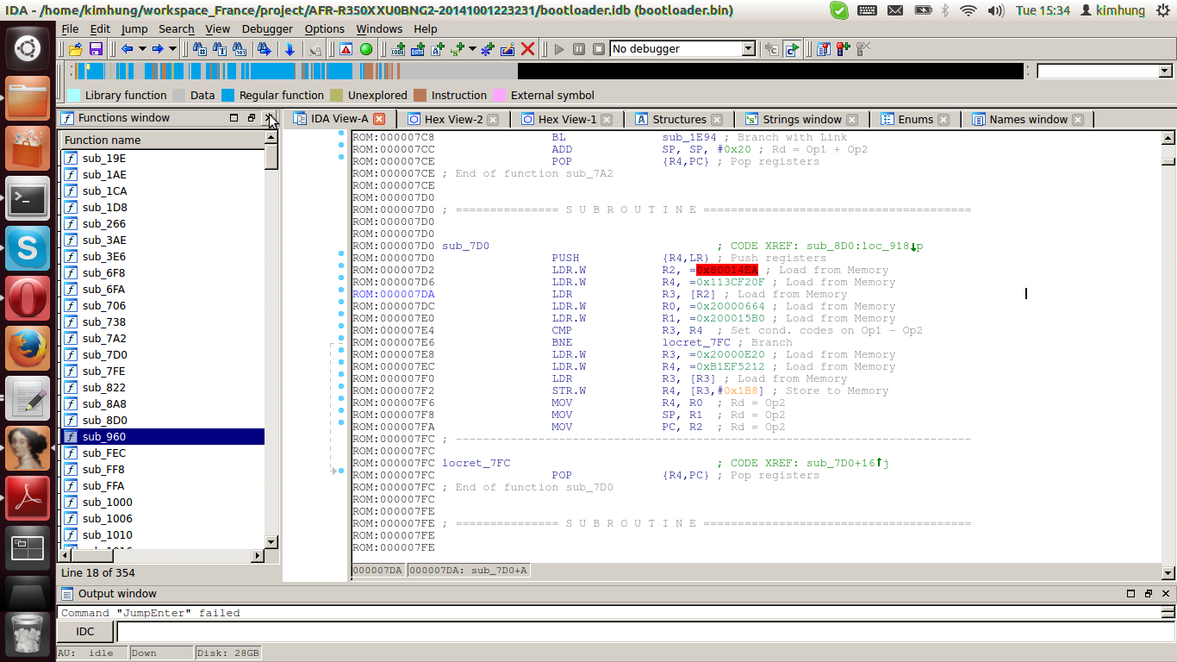

5. Vulnerability Assessment
5.1 Firmware Update validation method analysis (p47)

- The header is not farmiliar.

5.2 Binary Comparision:

5.3 Determining Base Address

1. search of all load register(LDR), find the range of address.

- True base address 1: ROM:0000097A ADR.W R0, aStartBootloade ; "\n\n\nstart bootloader\n"
- True base address 2: ROM:00000984 LDR.W R0, =0x40020000 ; Load from Memory

Function: sub_960: Start bootloader.
Function: sub_1F0A: find the image of the boot
Function: sub_1B8A: pit_check_signature
Function: ROM:000008D0 sub_8D0 : lreload the bootloader by DFU
Function: sub_6662
Mdr in the function in sub_960

You might want to look at this excellent explanation of the ARM boot process by Igor Skochinsky. Loading the boot loader at address 0, Architecture ARM, results in the first few lines
ROM:00000000 dword_0 DCD 0x20002DE0
ROM:00000004 DCD 0x20016AAD
ROM:00000008 DCD 0x2000E241
ROM:0000000C DCD 0x2000E245
ROM:00000010 DCD 0x2000E2B5
ROM:00000014 DCD 0x2000E32D
ROM:00000018 DCD 0x2000E3A5
ROM:0000001C DCD 0
ROM:00000020 DCD 0
So, 0x20002DE0 is the initial stack pointer, and 0x20016AAD is the entry point.
That entry point does not seem to be contained in the boot loader itself (which has 64 K + 256 bytes), but in the on-Chip ROM. From the answer:
Note that in the modern complex chips such as OMAP3 or Apple's A4 the first piece of code which is executed is usually not user code but the on-chip Boot ROM. It might check various conditions to determine where to load the user code from and whether to load it at all (e.g. it could require a valid digital signature). In such cases, the user code might have to conform to different start-up conventions.
So unless you can somehow dump the memory at 0x20016AAD, you won't be able to find out what the ROM does, and where within the ROM it jumps.
From a brief glance at the code, i'd assume the entry point to be a 0xBA40, or maybe 0xBAC0 which calls 0xBA40, because this calls 0x0960. The first few instructions there (especially at 0x097a)
ROM:00000960 PUSH.W {R4-R11,LR}
ROM:00000964 SUB SP, SP, #0x6C
ROM:00000966 ADD R0, SP, #0x90+var_88
ROM:00000968 MOVS R1, #0x34 ; '4'
ROM:0000096A BL sub_1A58
ROM:0000096E BL sub_8A8
ROM:00000972 BL sub_266
ROM:00000976 BL sub_1D8
ROM:0000097A ADR.W R0, aStartBootloade ; "\n\n\nstart bootloader\n"
ROM:0000097E BL sub_1E94
ROM:00000982 MOVS R1, #1
ROM:00000984 LDR.W R0, =0x40020000
ROM:00000988 BL sub_193E
seem to be an indication that the bootloader starts there, and sub_1E94 is a generic string output function (it gets called lots of times, every time with a string address in R0).

The loadd address of fota is 0x64400000
The load address wingtip update is 0x647E5000

The function begins the connection: sub_64418A84

You won't find more functions when you load the bin file to a different address. Also, as i explained in your previous question, the fact that the .bin file begins with what looks like an ARM bootinfo structure is a strong hint that the actual load address is 0. The on-Chip rom is at 0x20000000, but its contents aren't in your .bin file

27/05:
- Boot sequence in ARM:
Step 1: The reset
On startup, the processor will jump to fixed location at address 0x0 . This address should contain the reset vector and the default vector table. Reset vector is always the first instruction to be executed. The reset vector in this table will contain a branch to an address which will contain the reset code. Normally, at this stage, the rest of the vector table contains just the dummy handler- a branch instruction that causes an infinite loop (this is because this vector table is used very briefly and later on replaced by vector table in RAM after memory remap operation)
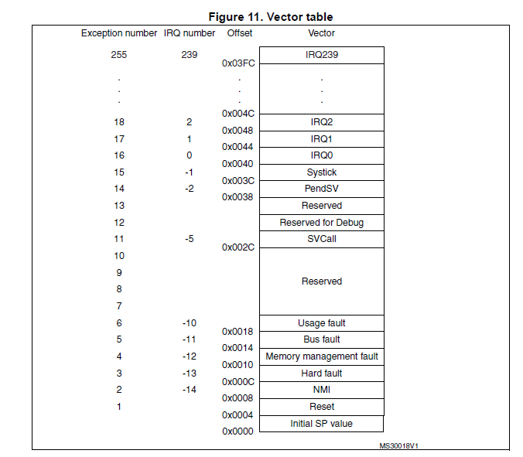

Step 2: The reset code
This reset code to which the jump has been executed from the reset vector will do the following tasks:
->Set up system registers and memory environment
->Set up MMU
->Setup stack pointers : initialize stack pointers for all ARM modes
->Set up bss section : zeroing the ZI data region, copying initialization values for initialized variables from ROM to RAM
->Set up hw : CPU clock initialization , external bus interface configuration,low level peripheral initialization etc
Step 3: Remap Memory
One of the job of the initial reset code will be memory remapping. At the time of power up, the processor jumps at fixed location 0x0.So, this is important to ensure there is some executable code present at this location at the time of power up. And to ensure this, some non volatile memory should be mapped to this address.
Vector table is located in RAM .However, ROM is located at 0×0 address and then during normal execution RAM is re-mapped to this location. Memory remapping can be achieved through hardware remapping, that is changing the address map of the bus. This can also be done through MMU.
Step 4: Setting up the external memory, loading and executing the OS image
External memory should be setup before loading an image to it (Refresh rate, clock etc),OS image can then be loaded from flash(assuming its NAND flash) to RAM. The OS image may be compressed in which case it needs to be decompressed before PC can be modified to point to the operating system entry point address.

